**SUMO (N TBD)**

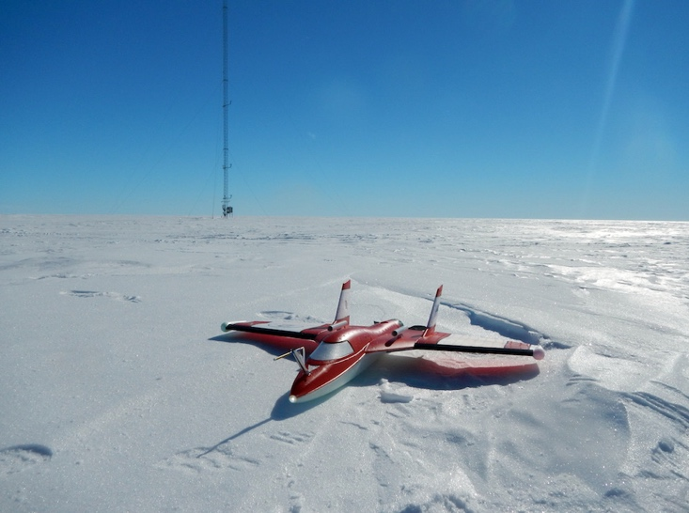

Table of Contents

Airframe System Description 2

Airframe System Specifications 3

Communication System Description 3

Sensor Package Description & Specifications 3

Emergency Procedures 4

Lost Link Procedure 5

Lost Communication Procedures 6

Launch/Recovery Procedure 7

SUMO Maintenance Log 8

SUMO Pre-Departure Checklist 9

SUMO Flight Operations Checklist: 10

# Airframe System Description

The Small Unmanned Observer (SUMO) has been developed by the Paparazzi community together with the Geophysical Institute of the University of Bergen, Norway. It is designed to support research in the lower atmospheric boundary layer. It uses industry standard sensors for temperature, air pressure, humidity and wind speed/direction.

The SUMO is based on the Multiplex Funjet. The goal was to have an aircraft that can fly fast to be able to operate in wind conditions up to 15m/s. To achieve an easy take-off for non-RC-enthusiasts it is equipped with a bigger propeller than normal (9x6). Some outer parts have been strengthened with glass fiber. The airframe has been modified to house a wide array of meteorological sensors within the aircraft structure.

# Airframe System Specifications

**Wingspan**: 787mm

**Length**: 750mm

**Electronic Speed Controller**:

**Flying Weight**:

**Motor**: 120 W

**Prop**: 9x6 folding prop

# Communication System Description

A Taranis Radio Controller (X9D+) is used as the primary means of communication. The Taranis operates at 2.4GHz. The SUMO has an additional telemetry connection to a ground station through a pair of XBee pro modules. These operate at a frequency of 2.4GHz as well.

# Sensor Package Description & Specifications

The sensor suite consists of a Sensirion SHT 75 temperature and humidity sensor, a Pt 1000 Heraeus M222 fast response temperature sensor, a MS 5611 pressure sensor, and a MLX90614 surface temperature sensor.

More detailed specifications for these sensors can be found at the University of Bergen SUMO page: <http://www.uib.no/en/rg/meten/57498/sumo>

# Emergency Procedures

Emergency Assumption of Control

* If there is any question that the UAS is no longer flying its programmed mission, the PIC will take manual control of the aircraft and return it to the landing zone if able and land it under Remote Control
* There may be minor problems that do not require emergency assumption of control. In these cases, the PIC can direct an autopilot landing or manually land the aircraft.

Accident/Incident Notification

* If the UAS is lost the crew will attempt to locate the downed aircraft. If the crew needs help they will request help from the OU Department of Aviation SOF. If the aircraft is recovered the crew will fill out the flight log, recover the log file, and make repairs as needed. The crew will write a detailed description of the event for OU flight safety and the FAA using the OU SMS program’s hazard/incident report IAW the OU Department of Aviation SMS program. The PIC/flight crew will inform the OU SOF of any abnormalities. The crew will wait to hear from the manufacturer before re-launching the UAS airframe.
* If the UAS crashes and damages any property or anyone is injured the crew will assess the situation.
  + Maintain personal safety for all parties concerned
  + Care for or request medical care for any injured parties
  + Notify any applicable local law enforcement agencies
  + Notify the OU SOF; OU SOF will contact OU parties IAW the already established OU
  + Department of Aviation Safety/Operational Risk Management program.
  + The PIC as well as flight crew, working observers plus any eye witnesses will write down exactly what happened and be ready to file a report with the local law enforcement and FAA if so directed. At any rate the report should be given to the OU SOF.

SUMO discrepancies will be written up in the OU maintenance aircraft forms. Information will be passed to the SOF and the manufacturer if necessary. Minor repairs can be made in the field and noted in the aircraft forms. It is in the nature of the aircraft for some parts to come off if a landing is harder than normal. If this occurs and there is no part damage the aircraft may be reassembled and flown.

Note these actions in the aircraft forms, so general wear can be tracked and greater understanding of the aircraft characteristics will be understood.

# Lost Link Procedure

The flight control system onboard the SUMO aircraft is very advanced and able to handle loss of signal very well. The SUMO has a flight plan loaded before launch but it can be changed midflight if required. At any time, the PIC can take control of the aircraft.

If Radio Control Signal is lost:

The SUMO will automatically realize that it has lost the RC connection and will use the GPS to return to the launch location. It will do this by first rising or descending to the “return home height – 300 feet” as programmed in prior to launch. It will then move horizontally to be over the launch location. If the RC signal has not returned by this point, it will slowly descend to the ground.

If GPS Signal is lost:

The SUMO Bixler 3 uses GPS for flightpath and position holding stability. If the GPS signal is lost, the aircraft will stay in its current flight path using the gyroscopes, accelerometers, and altimeter. The pilot will resume control and fly it to the ground.

If Radio Control and GPS signals are lost:

If both signals are lost, the aircraft slowly descends to the ground at whatever location it is currently at.

# Lost Communication Procedures

When a mode change or altitude change ‘will’ occur in the SUMO, the PIC will announce the change to the Observer. Each Observer will respond in turn. Additionally, at any time, if an Observer sees an aircraft entering the flight space, they will notify the PIC who will then take control of the SUMO and land as soon as possible. Each Observer is instructed to occasionally observe and communicate with the other Observers while performing their duties.

If at any time an Observer does not respond, the other Observers will visually locate the non-communicating Observer and report the status to the PIC, which will constitute a loss of communication. Lost communication between PIC and Observers necessitates termination of a flight.

# Launch/Recovery Procedure

The vehicle will be launched from the ground under PIC control. Recovery will be landing under PIC control.

# SUMO Maintenance Log

**Tail Number: N TBD**

Created: March 07, 2017

Autopilot System

Hardware:

Firmware:

Ground Station

Firmware:

Telemetry

Radio control of vehicle: Taranis Radio Controller (X9D)

Operates at 2.4 GHz

Radio link for data: XBee Pro series 2 Modem

Operates at 2.4 GHz

**Modifications**

**Date Modification & Notes**

# SUMO Pre-Departure Checklist

Date: _________________

**Packing List**

___ Vehicle

___ Batteries & LiPo bags

___ Controller (Taranis)

___ Laptop

___ Extra props

___ Tool box

___ First aid kit

___ Check lists and maintenance logs

___ Inverter*

___ Extension cords*

___ Canopy*

___ Chairs*

*If going to KAEFS and using UAS trailer, these may not be needed

# SUMO Flight Operations Checklist:

Date: ______________ Flight number: ________

Tail Number: N TBD

Location: _________________________________________________________________

PIC: _________________________________________________________________

Team: _________________________________________________________________

Flight pattern: _________________________________________________________________

Weather: _________________________________________________________________

Objectives: _________________________________________________________________

PRE-FLIGHT CHECKS

___ Perform visual inspection of the vehicle – props not damaged, props tight, center of gravity,

orientation & connection of RF, GPS, data transfer antennas, mechanical check

___ Turn on controller and check voltage

___ Check laptop (Mission Planner) and battery charge

___ Connect battery in vehicle

___ Check battery voltage: Battery Nr. _______ Voltage _________

___ Connect telemetry (baud 57600, select serial link, confirm heartbeat)

___ Confirm no Error Messages with Mission Planner

___ Confirm GPS fix type

___ Check sensors

___ Verbally Review flight plan – Upload flight plan from laptop

___ Vehicle at the launch point

___ Test audio communications among participants

___ Observers in location before take-off / good visual coverage

___ Check if all participants ready for flight

___ Arm motors & call clear prop

___ Takeoff, record takeoff time: __________

___ Land, record landing time: __________ Flight duration: ____________

POST-FLIGHT CHECKS

___ Check battery voltage after landing: Voltage _________

___ Disarm vehicle

___ Disconnect battery

___ Inspect vehicle

Remarks: